**Table Creation Assignment**

Following are the tables:

BRANCH (BID INTEGER, BRNAME CHAR (30), BRCITY CHAR (10))

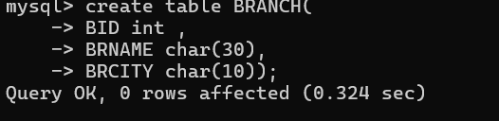

CUSTOMER (CNO INTEGER, CNAME CHAR (20), CADDR CHAR (35), CITY

CHAR(20))

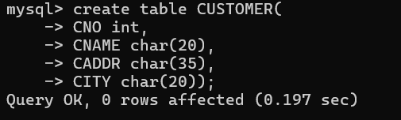

LOAN_APPLICATION (LNO INTEGER, LAMTREQUIRED MONEY, LAMTAPPROVED

MONEY, L_DATE DATE)



The relationship is as follows:

BRANCH, CUSTOMER, LOAN_APPLICATION are related with ternary relationship.

TERNARY (BID INTEGER, CNO INTEGER, LNO INTEGER).

Solve the Queries

1. Find the names of the customers for the “Aundh” branch.

12. List the names of the customers who have received loan less than their requirement.

3. Find the maximum loan amount approved.

4. Find out the total loan amount sanctioned by “Deccan “branch.

5. Count the number of loan applications received by “M.G.ROAD” branch.

6. List the names of the customer along with the branch names who have applied for

loan in the month of September.